Aggregation

📌 Definition:
# Source: AI Source: Provided by: [Data Path: Persons Table -> ID Column: 1, Name_En Column: Motasem Essam] -> From: [Chatgpt (GPT‑5 Mini)] on [12/9/2025]
Aggregation is a special type of association that represents a “has-a” relationship, where one object contains other objects, but those objects can still exist independently.

🧠 Simple idea:
# Source: AI Source: Provided by: [Data Path: Persons Table -> ID Column: 1, Name_En Column: Motasem Essam] -> From: [Chatgpt (GPT‑5 Mini)] on [12/9/2025]
Aggregation = “weak ownership” 🧩
Whole ↔ Parts (independent)

🔍 Key characteristics:
# Source: AI Source: Provided by: [Data Path: Persons Table -> ID Column: 1, Name_En Column: Motasem Essam] -> From: [Chatgpt (GPT‑5 Mini)] on [12/9/2025]
- 🔗 “Has-a” relationship
- 🧩 Weak association (loose coupling)
- ♻️ Child objects can exist without the parent
- ⚙️ Improves flexibility and reusability

📌 Real-world examples:
# Source: AI Source: Provided by: [Data Path: Persons Table -> ID Column: 1, Name_En Column: Motasem Essam] -> From: [Chatgpt (GPT‑5 Mini)] on [12/9/2025]
- 🏫 Department → Teachers
- 🧑‍🏫 School → Teachers
- 🚗 Team → Players
- 🏢 Company → Employees
👉 If the Department is deleted, the Teachers still exist.

📌 Example (Java-style):
# Source: AI Source: Provided by: [Data Path: Persons Table -> ID Column: 1, Name_En Column: Motasem Essam] -> From: [Chatgpt (GPT‑5 Mini)] on [12/9/2025]
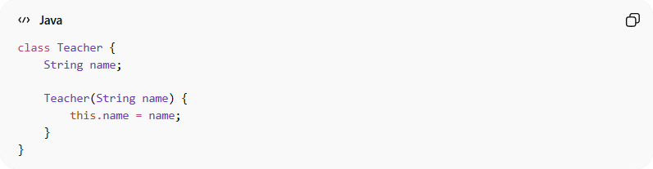
class Teacher {
String name;

Teacher(String name) {
this.name = name;
}
}
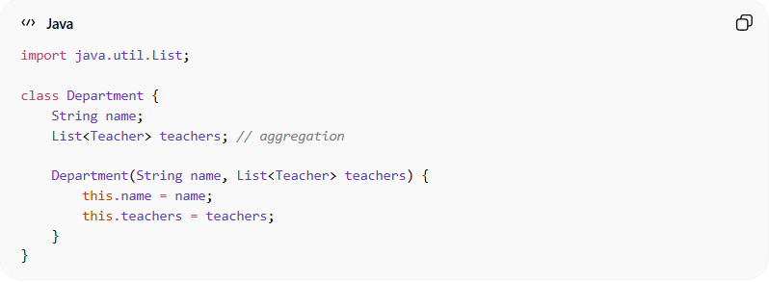
import java.util.List;

class Department {
String name;
List<Teacher> teachers; // aggregation

Department(String name, List<Teacher> teachers) {
this.name = name;
this.teachers = teachers;
}
}

Usage:
# Source: AI Source: Provided by: [Data Path: Persons Table -> ID Column: 1, Name_En Column: Motasem Essam] -> From: [Chatgpt (GPT‑5 Mini)] on [12/9/2025]
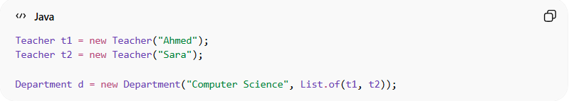
Teacher t1 = new Teacher("Ahmed");
Teacher t2 = new Teacher("Sara");

Department d = new Department("Computer Science", List.of(t1, t2));
👉 Teachers exist independently of the department.

🔄 Relationship diagram:
# Source: AI Source: Provided by: [Data Path: Persons Table -> ID Column: 1, Name_En Column: Motasem Essam] -> From: [Chatgpt (GPT‑5 Mini)] on [12/9/2025]
Department ◇────── Teacher
(◇ represents aggregation — weak “has-a”)

🆚 Aggregation vs Composition:
# Source: AI Source: Provided by: [Data Path: Persons Table -> ID Column: 1, Name_En Column: Motasem Essam] -> From: [Chatgpt (GPT‑5 Mini)] on [12/9/2025]
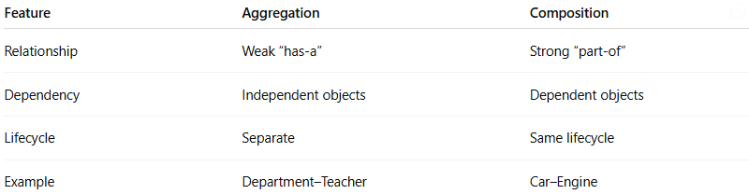
Feature | Aggregation | Composition
Relationship | Weak “has-a” | Strong “part-of”
Dependency | Independent objects | Dependent objects
Lifecycle | Separate | Same lifecycle
Example | Department–Teacher | Car–Engine

🎯 Why it is important:
# Source: AI Source: Provided by: [Data Path: Persons Table -> ID Column: 1, Name_En Column: Motasem Essam] -> From: [Chatgpt (GPT‑5 Mini)] on [12/9/2025]
- 🧩 Models real-world “has-a” relationships
- 🔄 Promotes loose coupling
- ♻️ Enhances code reuse
- 🧠 Improves system design flexibility

🎯 Summary:
# Source: AI Source: Provided by: [Data Path: Persons Table -> ID Column: 1, Name_En Column: Motasem Essam] -> From: [Chatgpt (GPT‑5 Mini)] on [12/9/2025]
Aggregation represents a weak “has-a” relationship where the child objects can exist independently of the parent object.

